# Solar Energy Corporation of India Limited (SECI)

1. **BACKGROUND**

India, as one of the signatories to the 2015 Paris Agreement, has made a commitment to reduce emission intensity of the economy and to increase generation capacity from clean energy sources.

Towards this objective, the Ministry of New and Renewable Energy (MNRE) is spearheading one of the world’s largest renewable Energy (RE) programmes, targeting 500 GW of installed electricity capacity from non-fossil sources by 2030 and net zero by 2070.

Solar Energy Corporation of India Limited (SECI) was set up in 2011 to facilitate the implementation of National Solar Mission (NSM) and to achieve the targets set forth by it. SECI was initially incorporated as a section 25 company (Not-for-profit) under the Companies Act, 1956. In the year 2015, it was converted into a Section-3 company. SECI is a Schedule- A Central Public Sector Undertaking (CPSU) and was accorded Miniratna Category I status in April 2023.

1. **BUSINESS AREAS**
2. **Implementation of Govt. Schemes/tenders**

SECI is an implementing agency of MNRE for issuing tenders for development of solar projects, wind power and hybrid projects on pan-India basis on the basis of Standard bidding guidelines issued by the Government. Presently, over 68 GW of Project capacity has been awarded to various developers through competitive bidding process. Out of this, more than 21 GW of capacity has been commissioned and rest of the projects are under various stages of implementation (as on 30.06.2024).

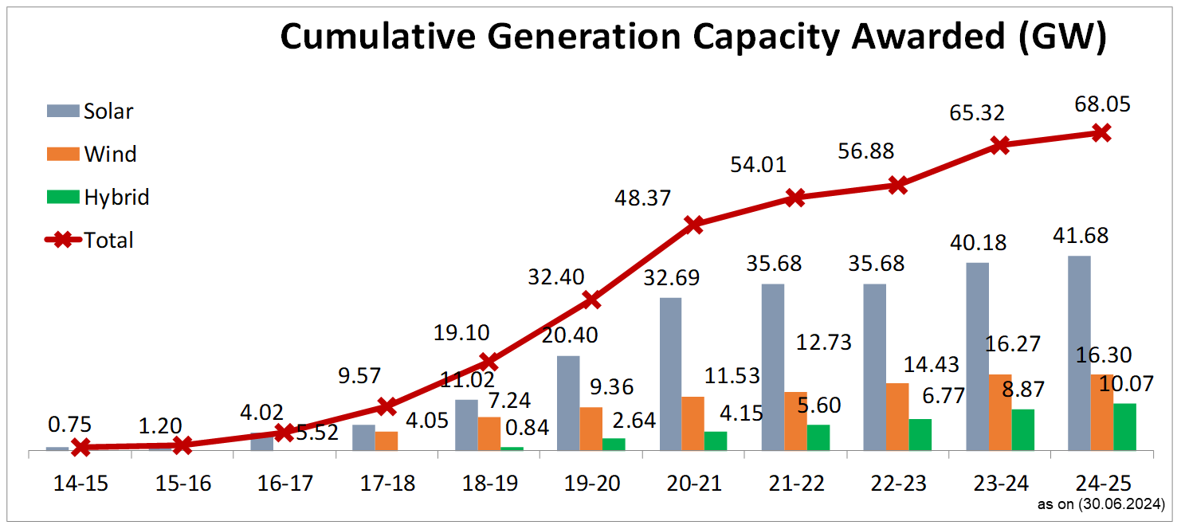

In these projects, SECI is the power procurement intermediary between the project developers and Distribution Companies (Discoms) and enters into 25-year Power Purchase Agreements (PPAs) and Power Sale Agreements (PSAs) with these entities respectively. Under this model, SECI offers payment security to developers and undertakes to collect payment from Discoms. SECI's payment security mechanism has helped in providing bankability to the agreements, resulting in very good participation in its tenders and in lowering of the tariffs.

SECI has also played a pivotal role in promoting rooftop solar PV projects through competitive bidding route in the country under various schemes of MNRE. SECI has helped in commissioning of over 5000 projects with an aggregate capacity of 370 MW in various States/Union Territories through developers.

SECI is also implementing various schemes of MNRE in which it plays the role of disbursing Central Financial Assistance (CFA) to the project implementing agencies on the basis of pre-defined scheme milestones. Major schemes are- Solar Parks Scheme, Canal Top/ Canal Bank Scheme, Scheme for Defence Establishments and CPSU scheme.

1. **Own Projects**

SECI has set up 122.7 MW of solar projects on pilot scale through its own investment and further projects are under construction (as on 30.06.2024).

|  |  |  |  |  |
| --- | --- | --- | --- | --- |
| **S. No.** | **Name** | **Location** | **Capacity (MW)** | **Status** |
| 1 | Solar | Badi Sid, Rajasthan | 10 | Commissioned |
| 2 | Rooftop solar | Andaman & Nicobar Islands | 1 | Commissioned |
| 3 | Solar | Kolar, Karnataka | 10 | Commissioned |
| 4 | Solar + BESS | Lakshadweep | 1.7 | Commissioned |
| 5 | Solar + BESS | Rajnandgaon, Chhattisgarh | 100 | Commissioned |
| 6 | Floating solar | Getalsud Dam, Jharkhand, | 100 | Under implementation |
| 7 | Solar | Ramagiri, Andhra Pradesh | 300 | Under Govt. approval stage |
| 8 | Solar | Radhanesda, Gujarat | 700 | Under Govt. approval stage |
| 9 | Solar | Neemuch, Madhya Pradesh | 200 | Under Govt. approval stage |

# Project Management Consultancy

SECI also offers project management consultancy (PMC) services to other Govt. agencies/PSUs/Private entities for RE projects including project conceptualization, Detailed Project Report (DPR) preparation, tender documents preparation and bid management, construction management and commissioning. Under PMC services more than 380 MW capacity has been commissioned by SECI. Major completed projects include 50 MW project for Indian Renewable Energy Development Agency (IREDA), 50 MW for THDC, 16 MW for Bharat Electronics Limited (BEL), 10 MW for Bharat Dynamics Limited (BDL) and 224 MW for Singareni Collieries Company Limited (SCCL).

# Power Trading

SECI is a Category-1 licensee for trading of power on pan-India basis. It is the power procurement intermediary for projects being set up through its tenders, procuring power from developers and selling to Discoms though long term PPAs/PSAs. SECI is the premier trader of RE power in the country. It has cumulatively signed PSAs of more than 54623.64 MW (as on 30.06.2024).

1. **FINANCIAL PERFORMANCE**

SECI has an authorized share capital of Rs. 2000 Cr. of which the paid up share capital is Rs. 1354 Cr.

SECI is a profit-making company since the year 2014-15. The company has demonstrated steady growth every year, both in terms of Revenue and Profits. For FY 2023-24, the company’s Revenue from Operations is Rs. 13035.07 Cr (Prov.) and its PBT is Rs. 584.45 Cr.

Further, Net-worth of the company as on 31.03.2023 is Rs. 2,811.76 Cr.

SECI has the highest credit rating of [ICRA]AAA/ A1+.

1. **NEW INITIATIVES**

In line with rapidly evolving RE sector, SECI is foraying into new business initiatives such as PLI scheme, Green Hydrogen & Green Ammonia, Greening Electric Vehicle Charging, Energy Storage, supply of RE to Commercial and Industrial (C&I) consumers etc. and engaging with relevant stakeholders.

*****